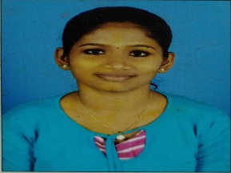**AMITHA KRISHNA M**

MALIKAKANDI PARAMBA BANK CROSS ROAD

CALICUT-673001

EMAIL ID: [amithakm77362@gmail.com](mailto:amithakm77362@gmail.com)

Ph:7736256945

OBJECTIVE

To become a contributing computer programmer, in an organization for its success, by applying the business practices, through innovative solutions, and constantly updating my skills.

EDUCATION PROFILE

* B.E.M.G.H.S. S Manachira Kozhikode.

SSLC

* GOVT G.H.S.S Azhchavattom

Plus, two

* GOVT ITI(W) Malikadavu

Information communication technology and system maintenance

* NSTI calicut

Pursuing Advanced diploma in it and cloud computing

SKILLS

* HTML
* CSS
* WINDOWS AND UBUNDU
* MS OFFICE
* JAVA
* TROUBLESHOOTING A PC
* Languages known: Malayalam, Tamil, Hindi, English, Thelungu.

PROJECT

**EDUKNIGHTS**

Eduknights is an open online course catalogue website, a project done in the year 2020 as part of curriculum.

ROLE: Team lead, there was 4 members in our group. Complete the project EDUKNIGTS and hosted though AWS successfully.

HOBBIES

Reading books and listening music.

INTERESTS

* WEB DESINING/DEVELOPMENT
* TEACHING
* HARDWARE MAINTANANCE
* SOCIAL WELFARE

PERSONAL PROFILE

Birthday : April 30 1998

Age : 23A

Gender : female

Civil status : single

Father name : Thyagarajan M

Mother name : Anitha M